Iam task
- Create one IAM user and assign EC2 and S3 full access roles.
First I have Navigated to IAM service, then clicked on users to create an user
- Enter username
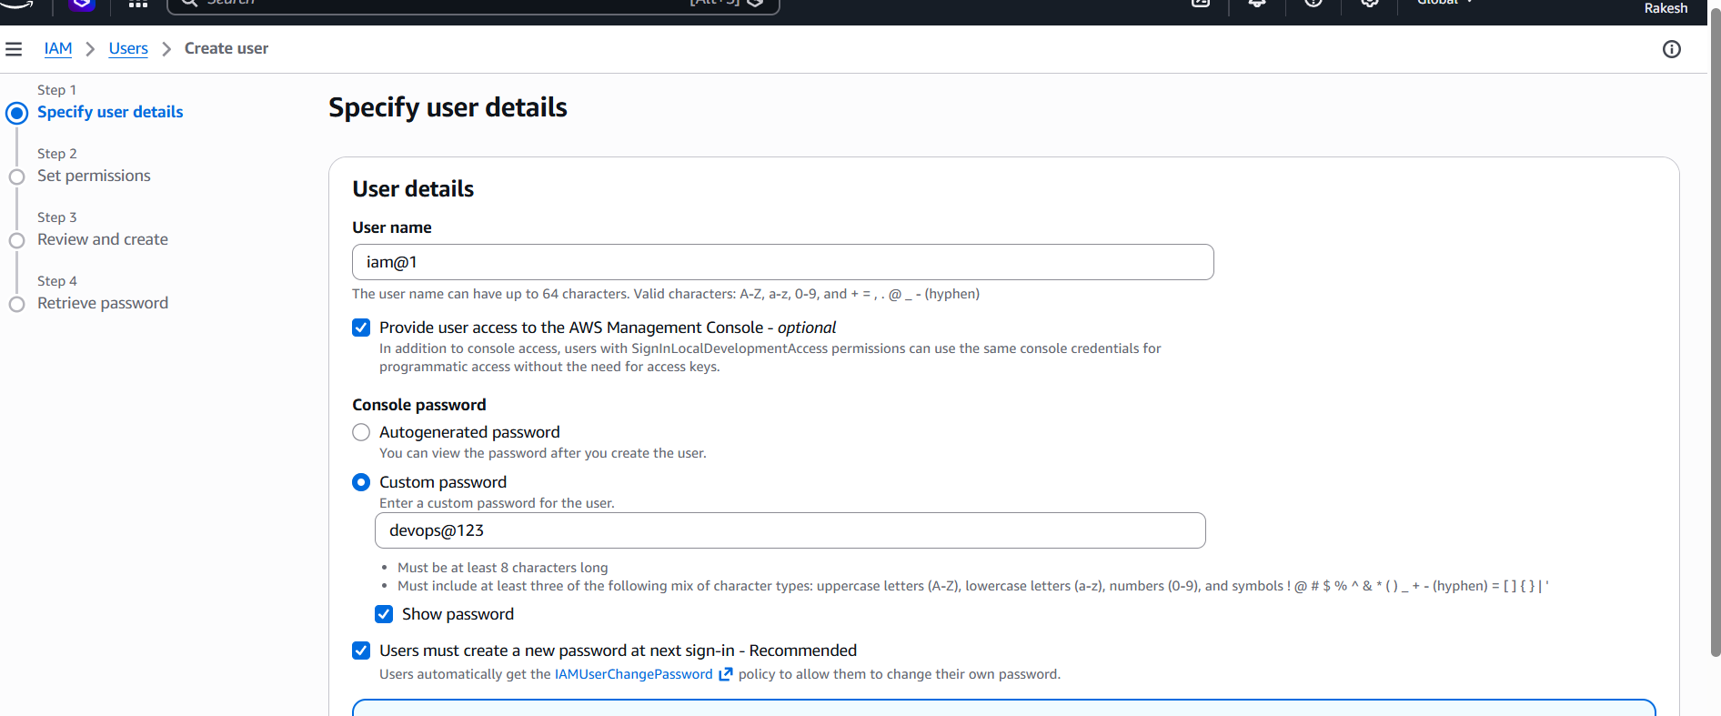

I have enabled AWS Management Console access
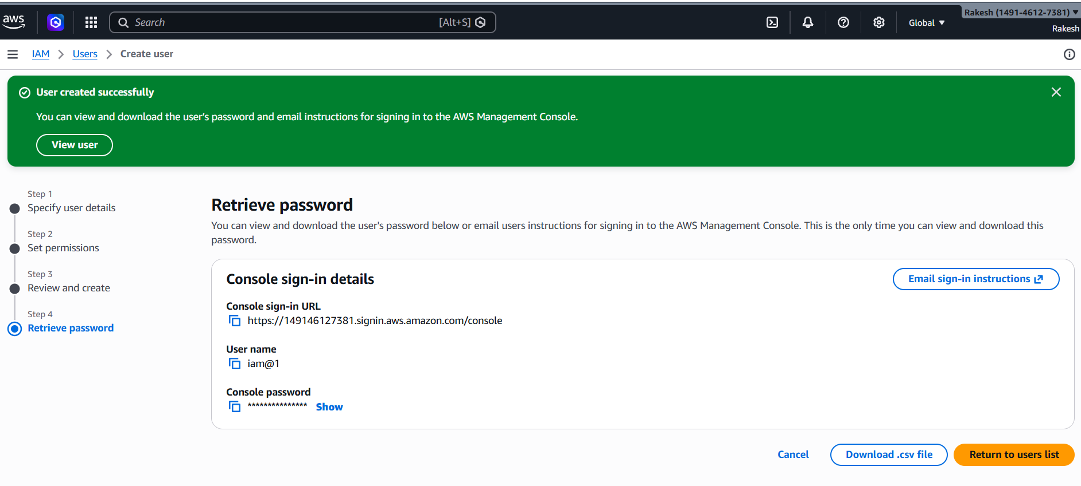
Set Permissions
- Select Attach policies directly
- Search and attach the following policies:
S3fullaccess
Ec2 full access
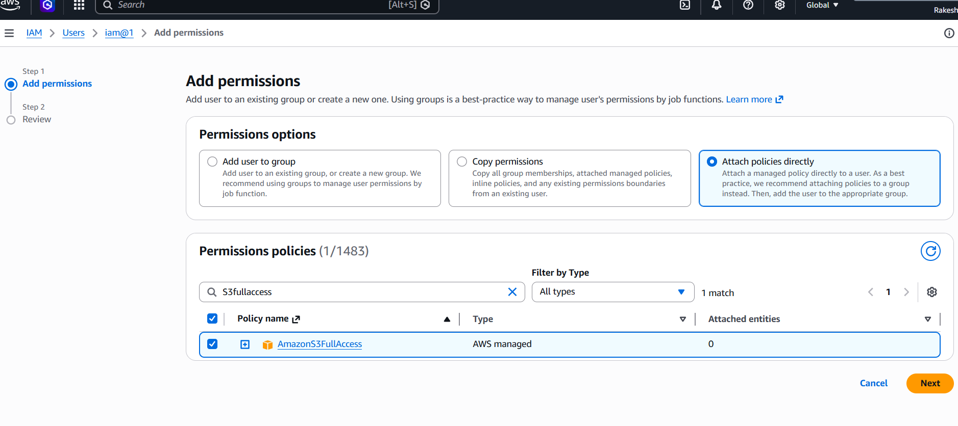

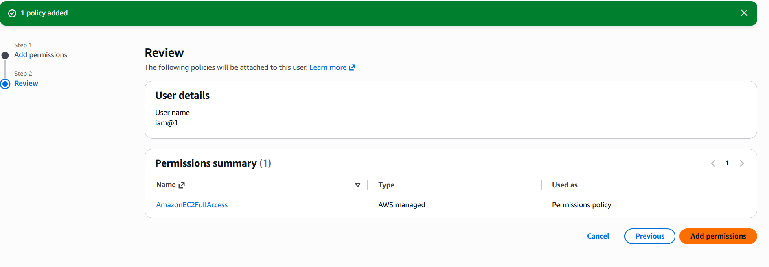
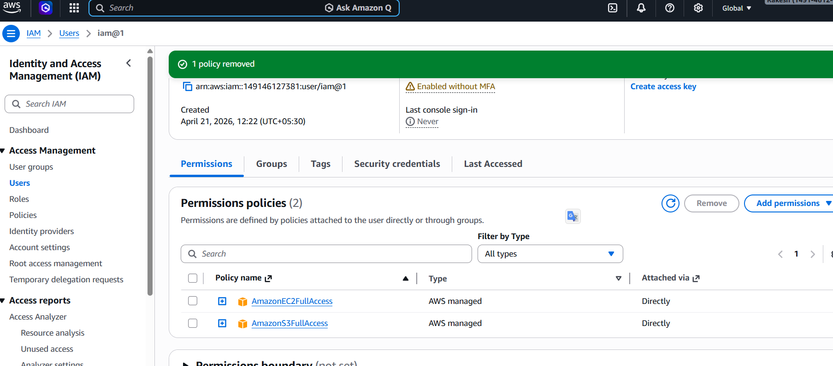
2. Create one group in IAM and assign read access for EC2.
Create IAM Group
- In IAM Dashboard → Click User Groups
- Click Create group
- Enter group name
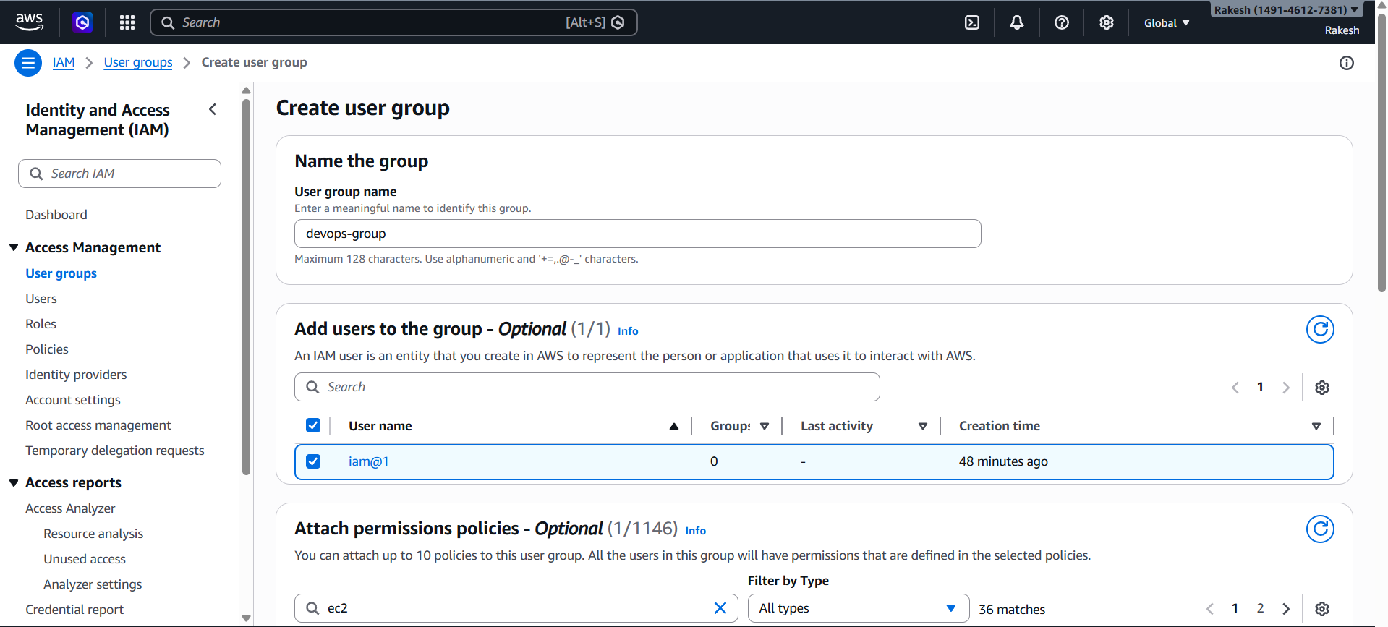
Attach Permissions
Under Attach permissions policies
Search and select:
-AmazonEC2ReadOnlyAccess
This policy allows users to:
View EC2 instances

Check instance status
View configurations and resources
Cannot create, modify, or delete resources
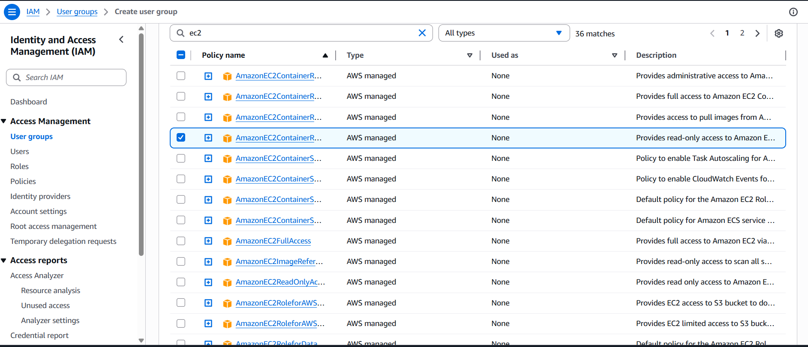
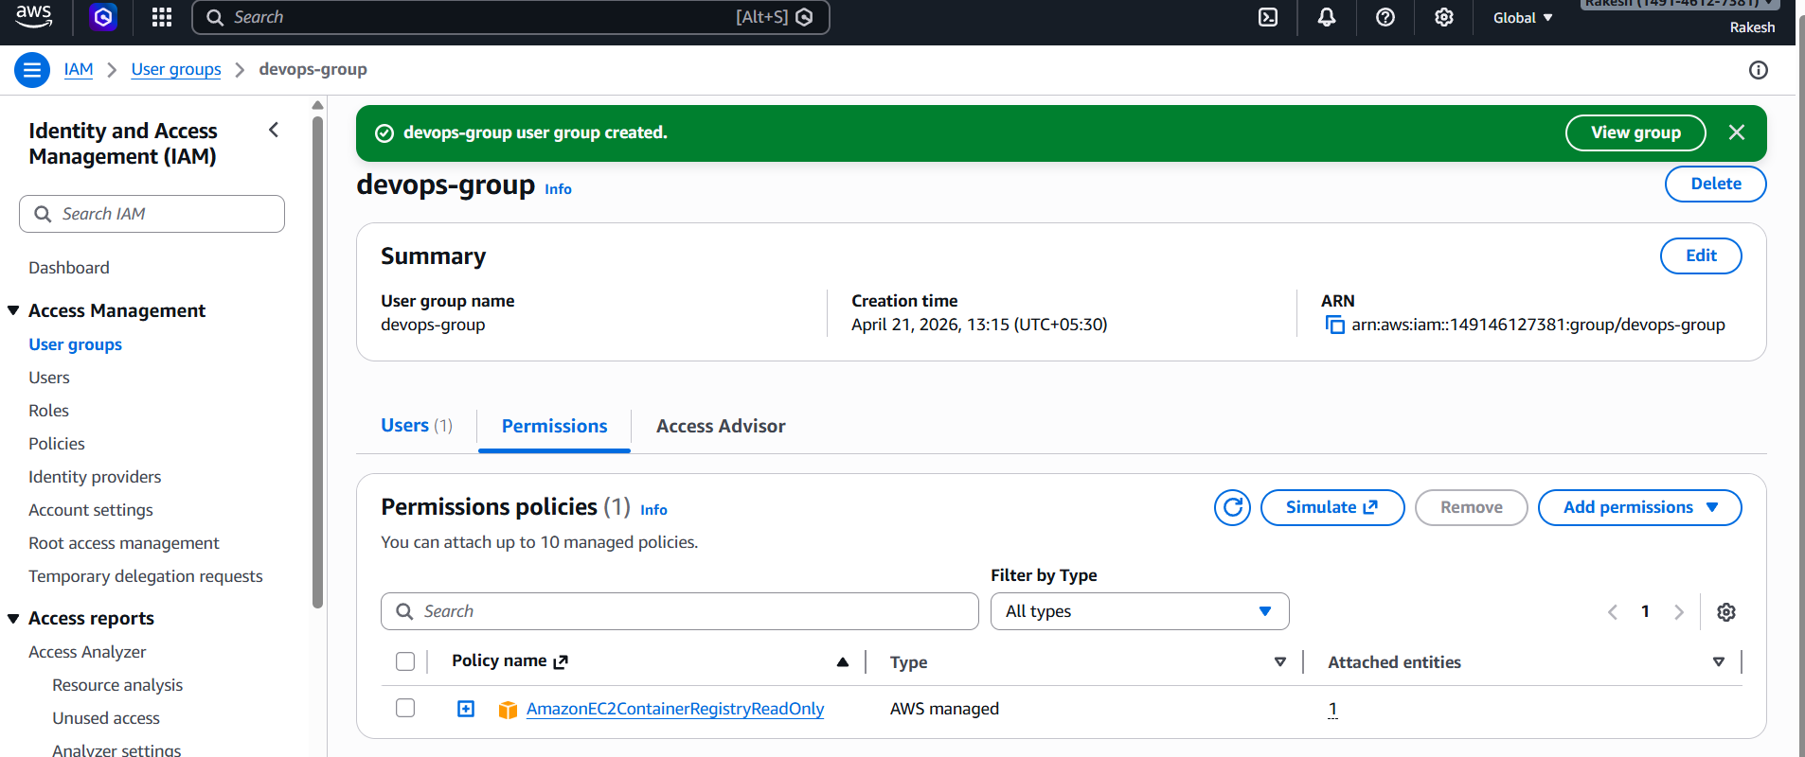
3. Create a new user named "Devops" and add to the group created in task 2.
Create New IAM User
In IAM Dashboard → Click Users
Click Create user
Enter username: Devops
Select Access Type:
- Enable AWS Management Console access (for login)
- Click Next
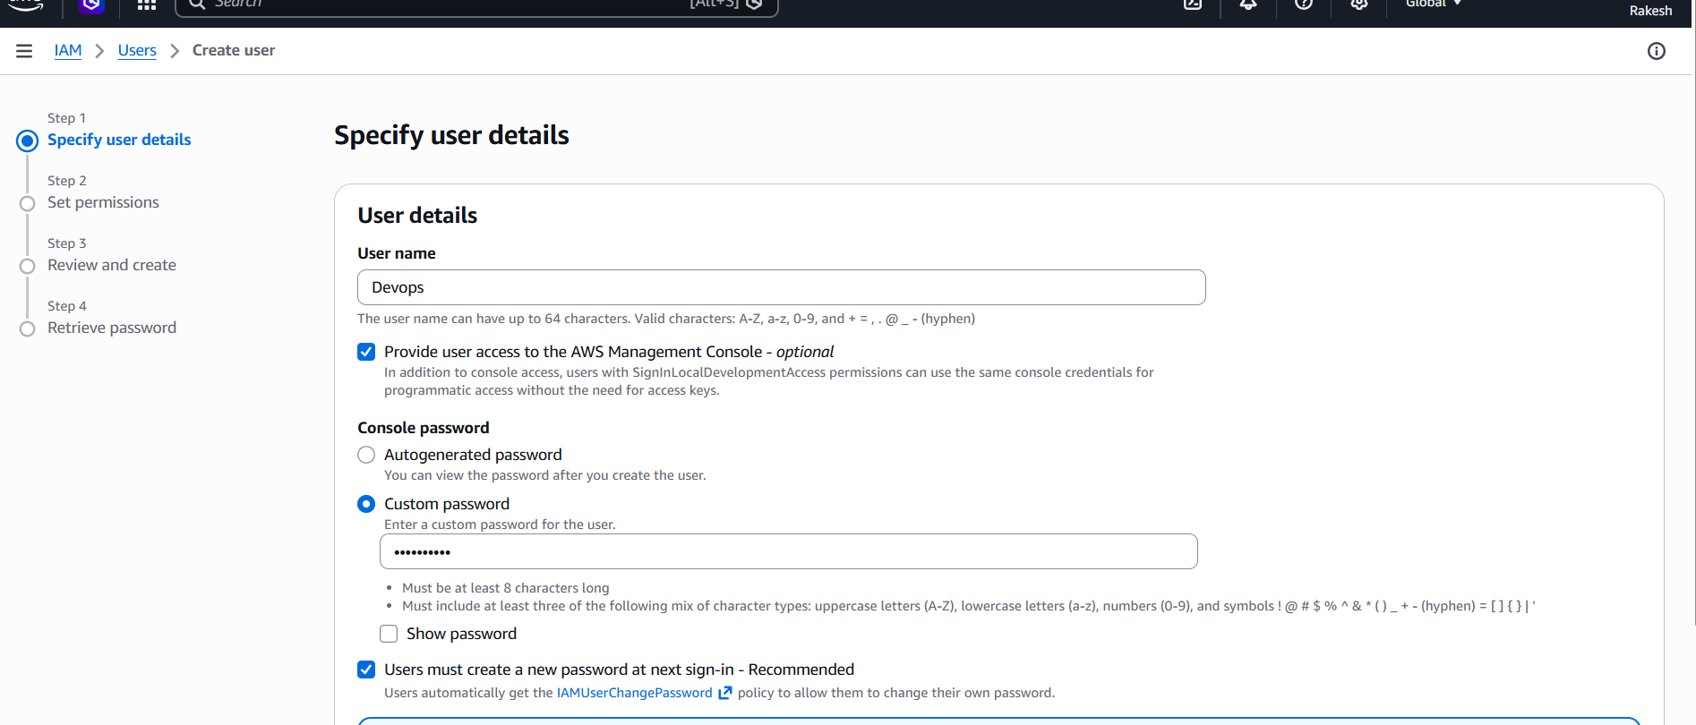
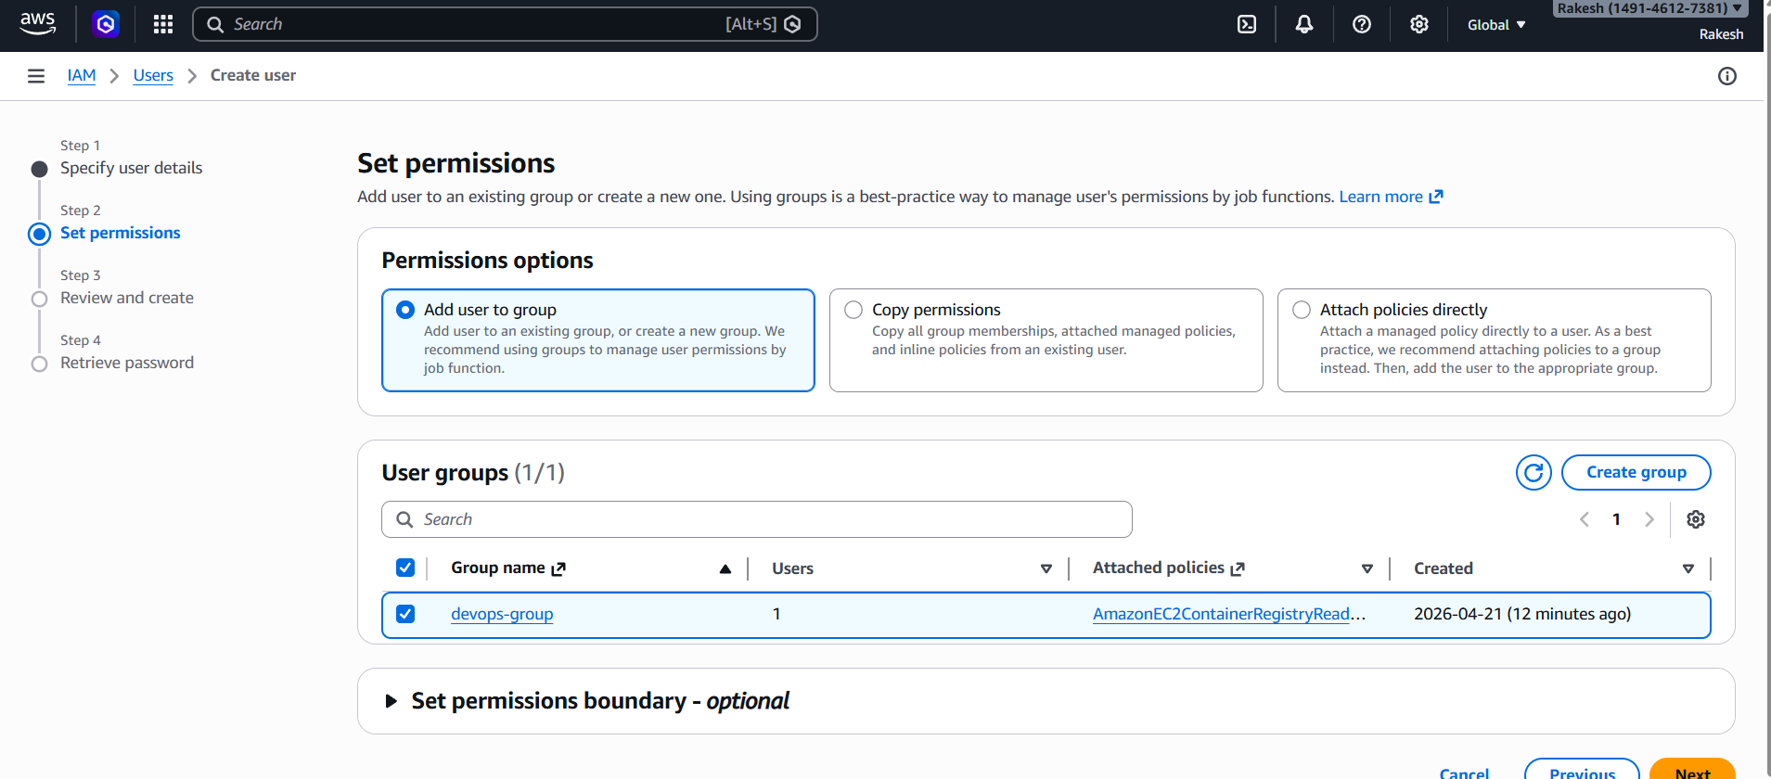
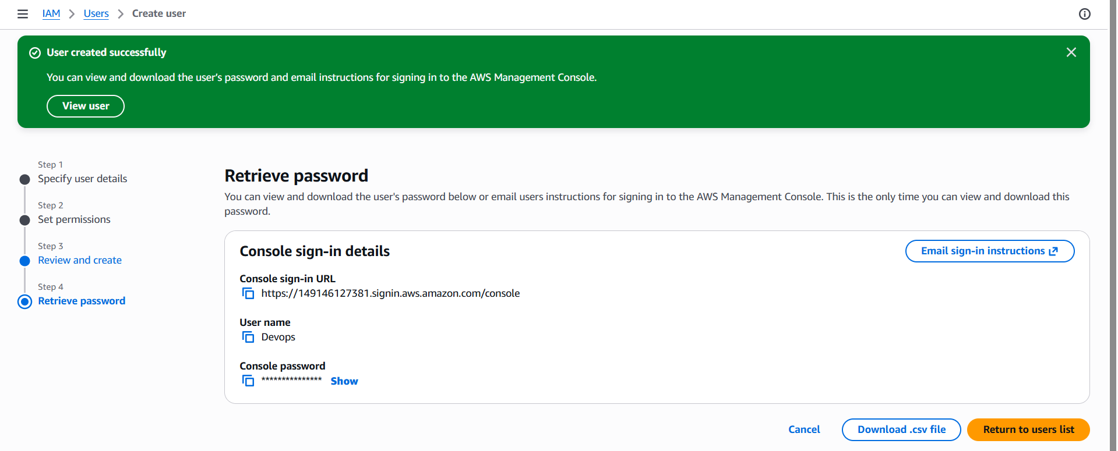
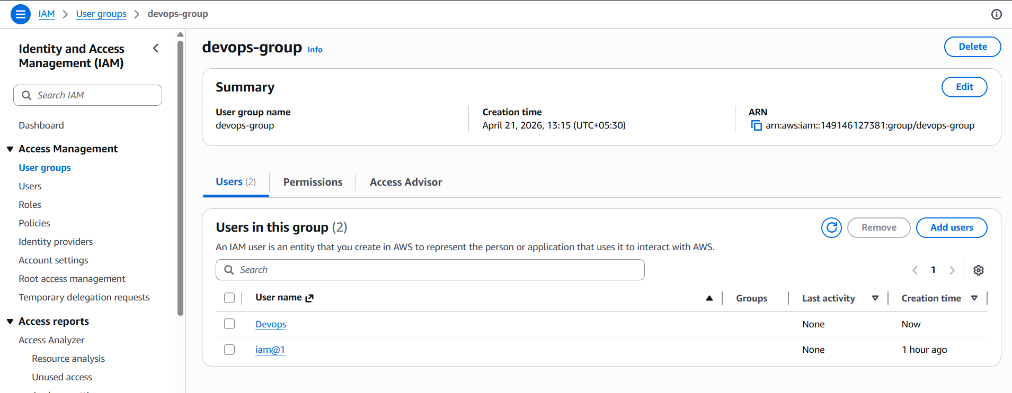
4. Write a bash script to create an IAM user with VPC full access.
I have created a file and wrote a bash script to create an IAM user with VPC full access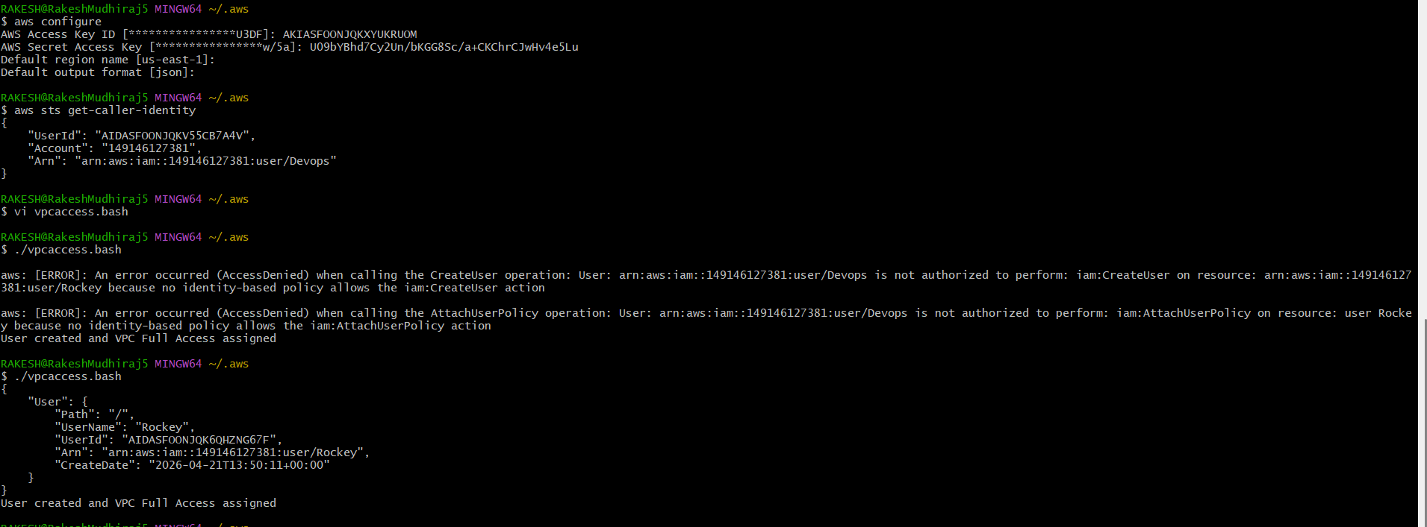

Allowed permissions to execute
Chmod +x

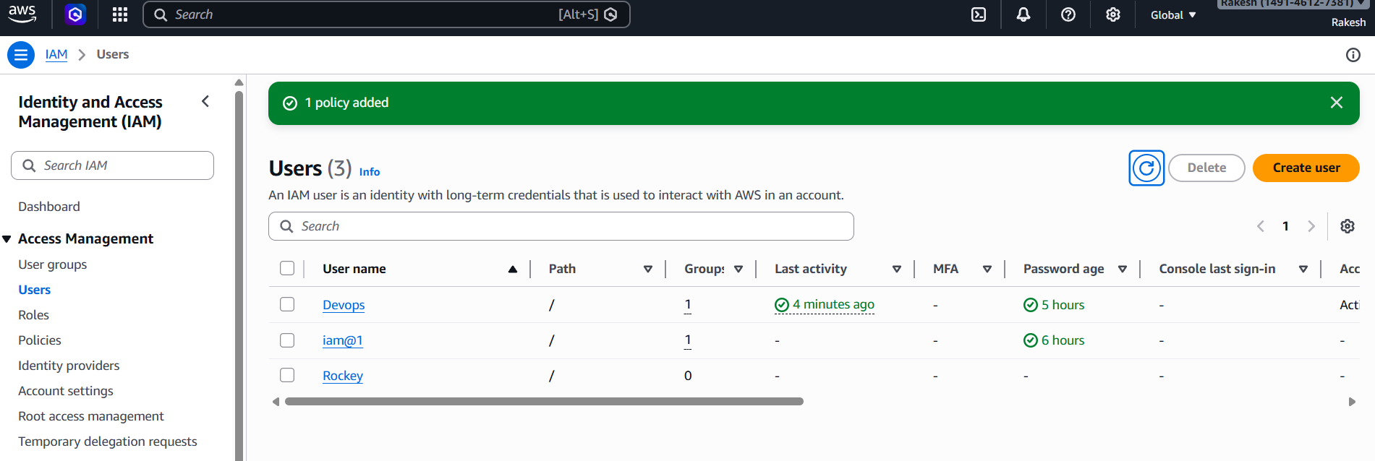

5. Create an IAM policy to allow EC2 access for a specific user in specific regions only.
First I have created policy
I have added json policy
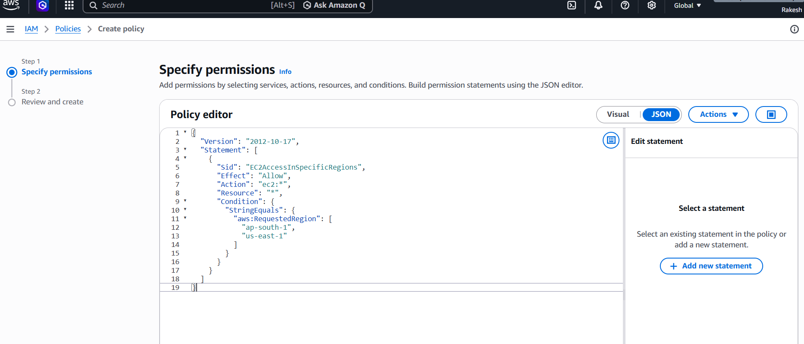
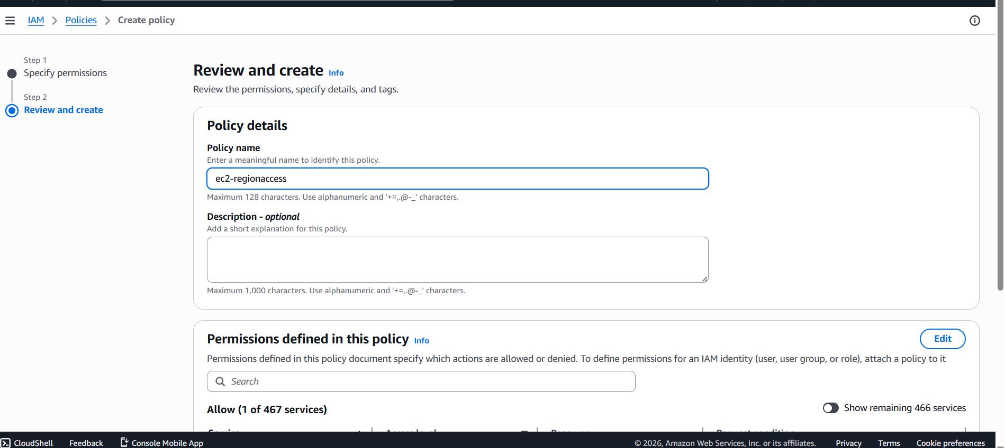

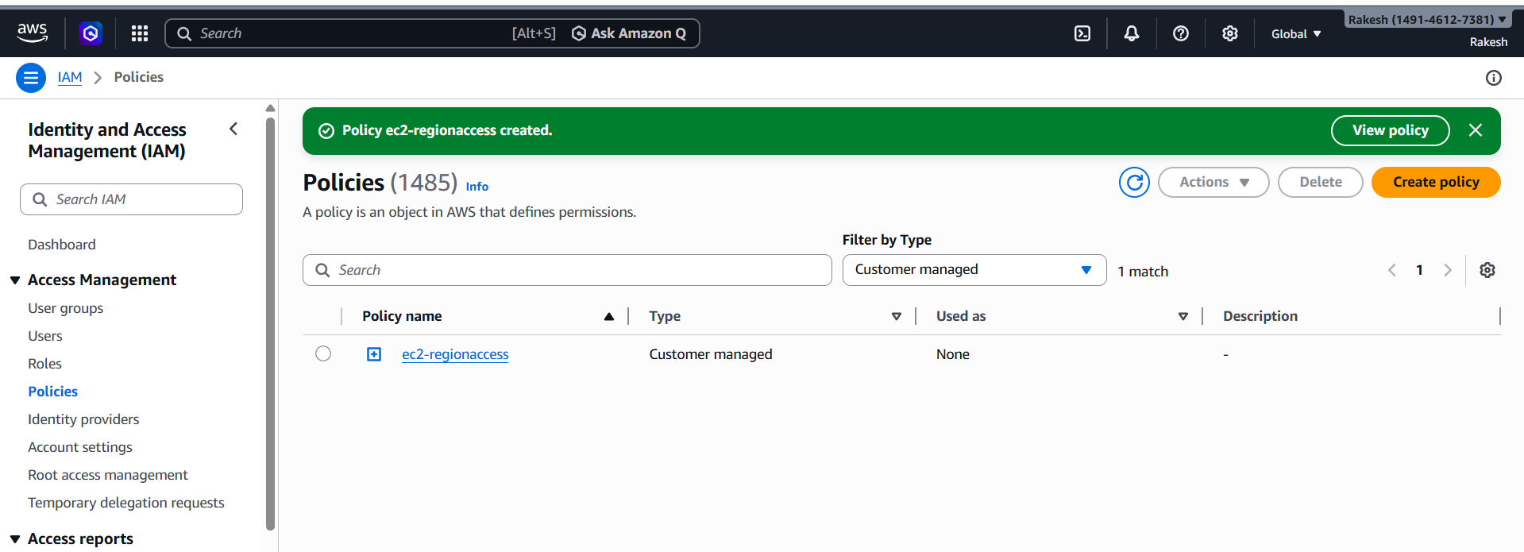

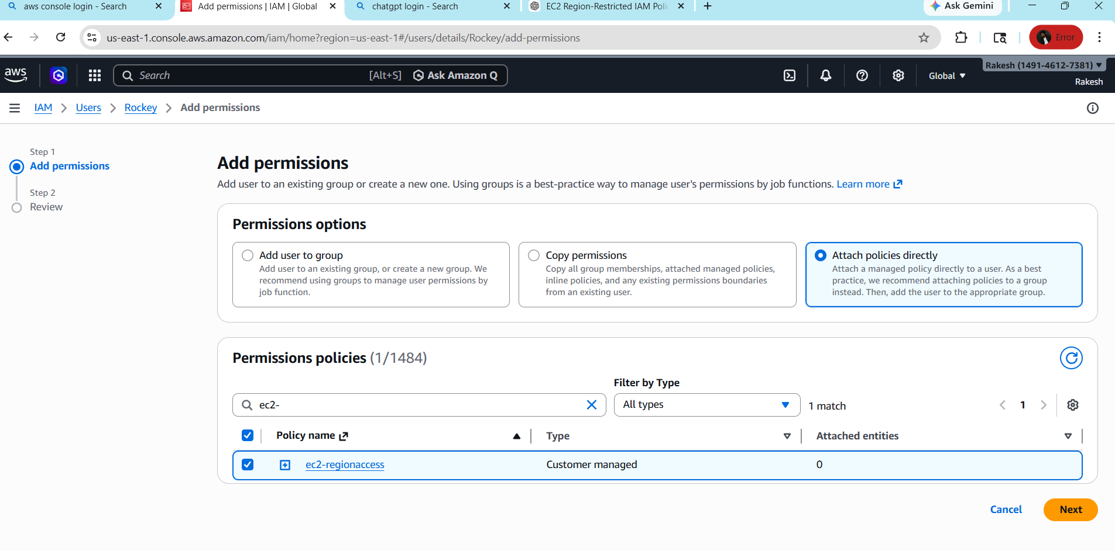
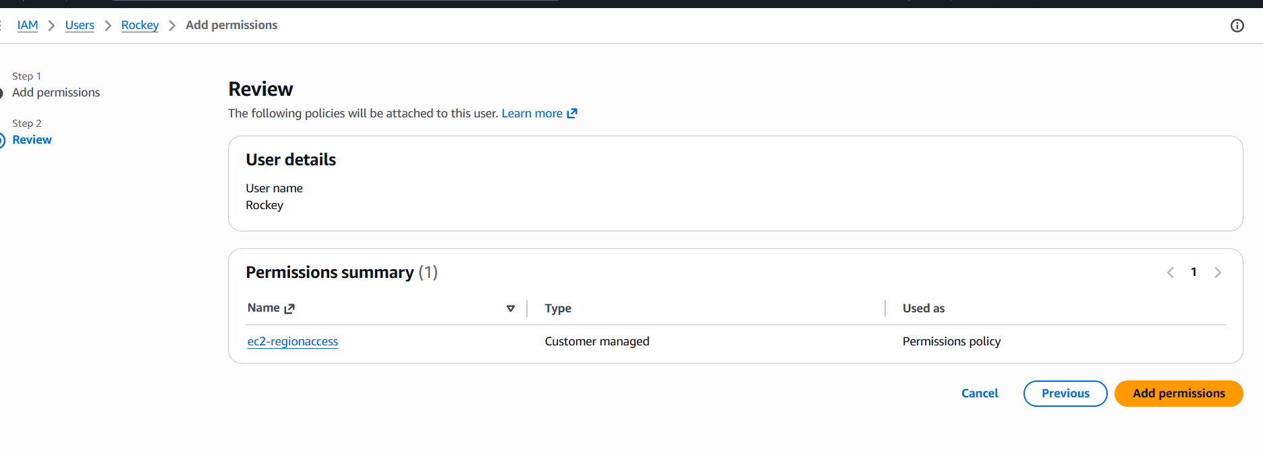
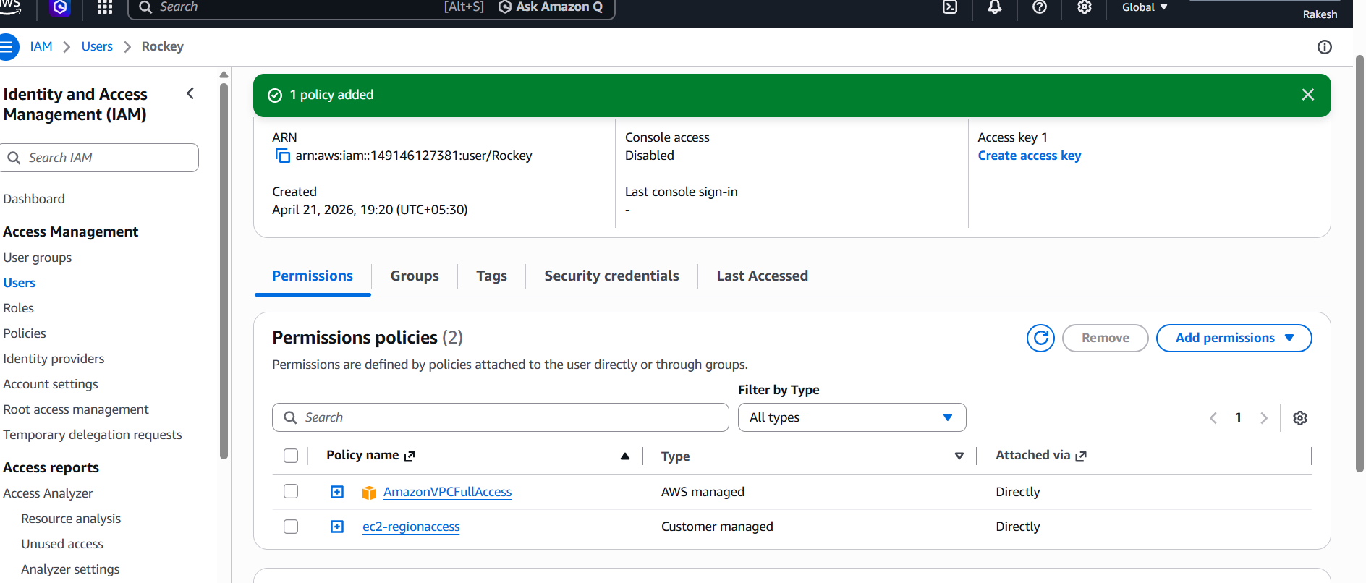
6. We have two accounts: Account A and Account B. Account A user should access an S3 bucket in Account B.
go to amazon S3---Buckets--create bucket name amzw-s3-bucket-(my name or any unique name
will be give)--create bucket--then go to add anyfiles in that file and folders we can see our files
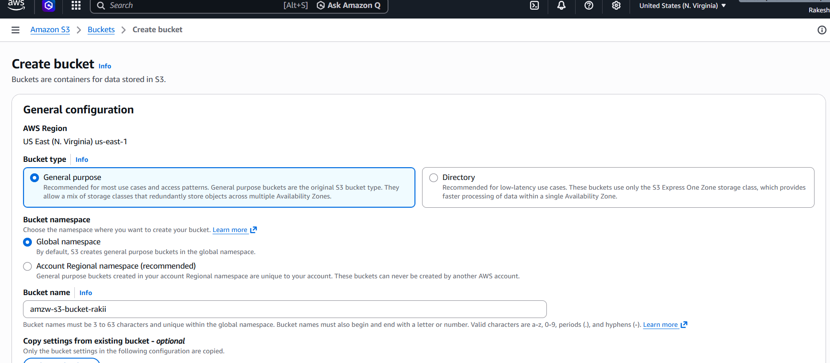

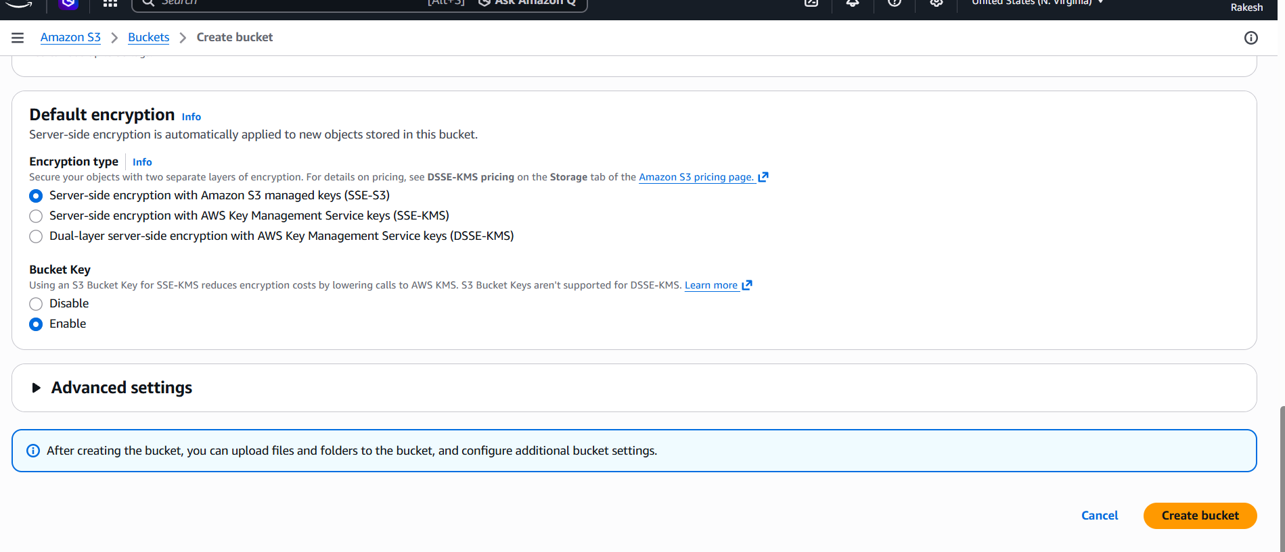
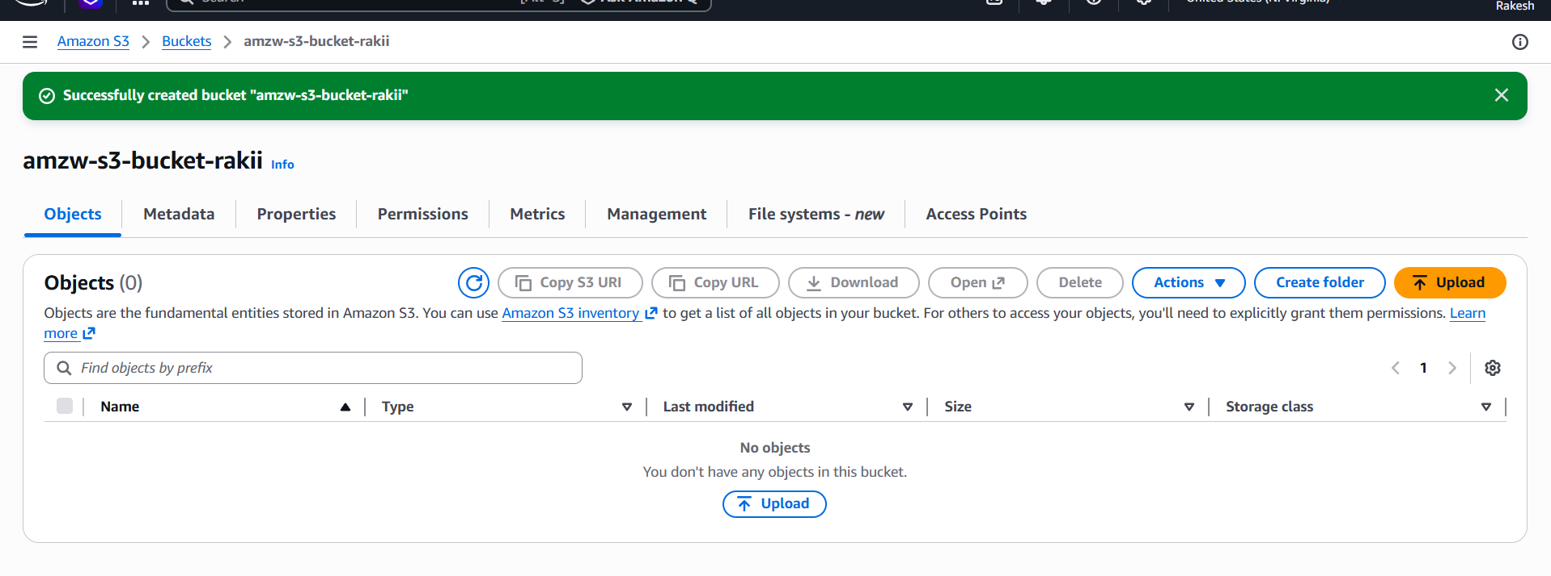
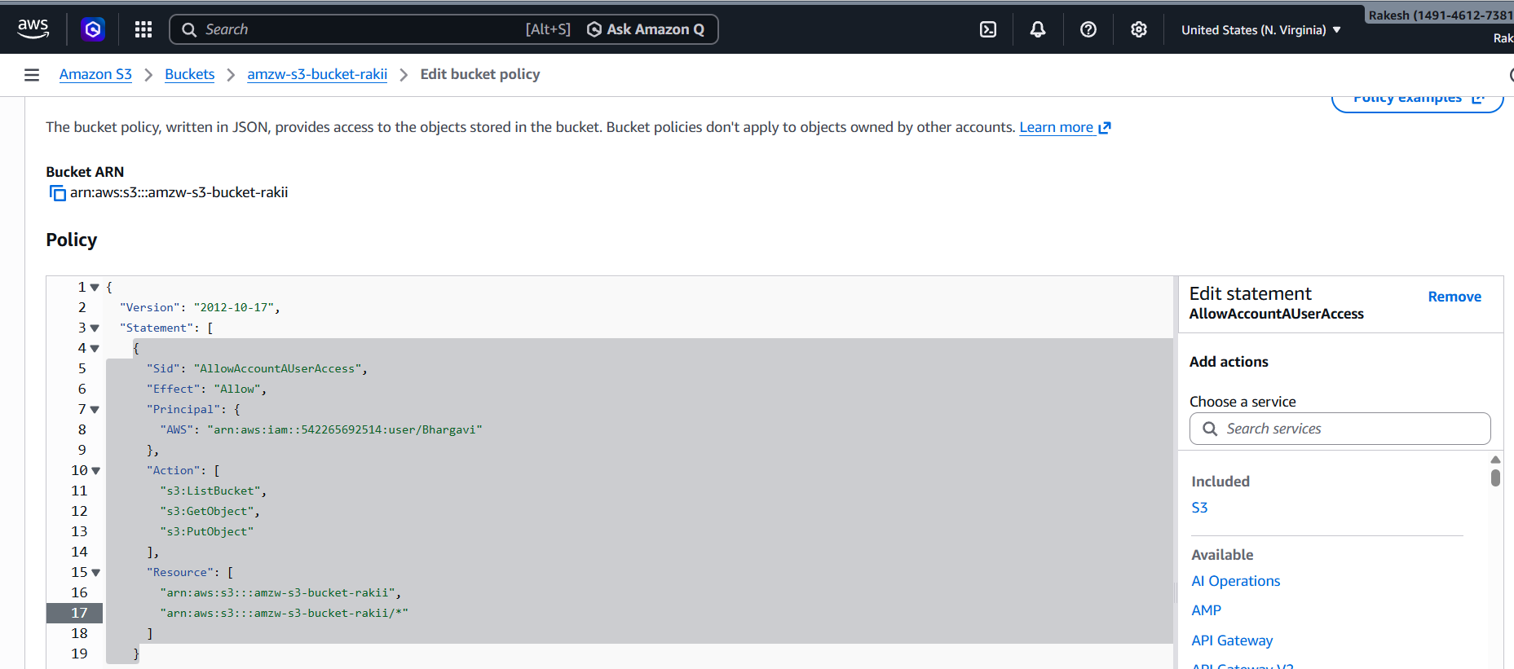
in this 1st we can give sony user id-in last line I want to give my bucket arn number.-->I able to
acces by bucket in sony git bash-she will configure with their access keys and password -aws s3
ls s3://amzn-s3-bucket-bv ….>here I can see my bucket as been showed in her git bash.

